Bug Reporting in Teamwork with templates

Teamwork is a simple to use, yet powerful project management tool. In fact, they are great to use for bug tracking .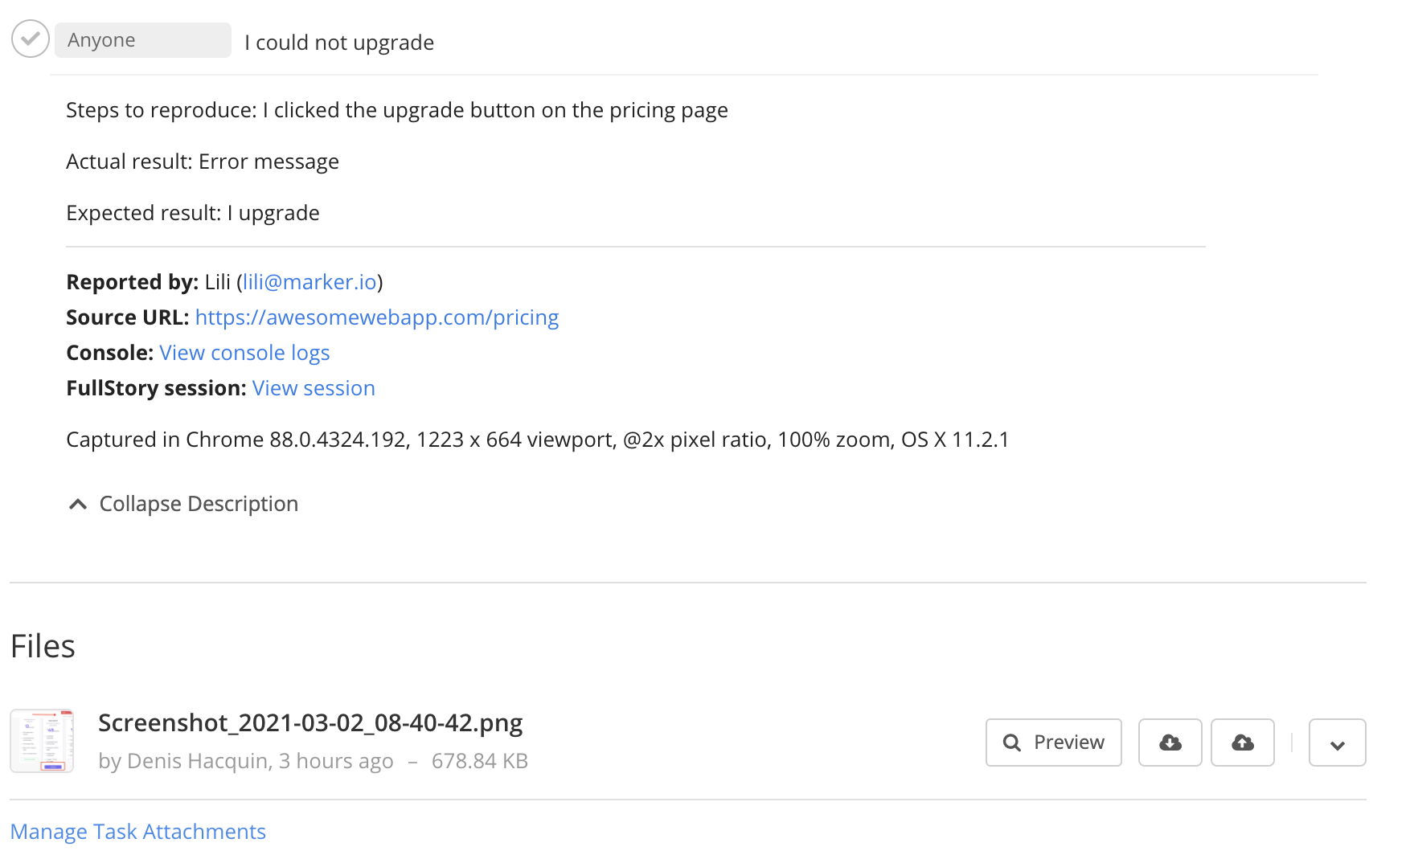

Description:

As you can see, all the elements for a bug report are in there.

However, creating such a detailed bug report in Teamwork can be overwhelming for clients, users, and nontechnical colleagues. It will take them a long time to create these reports.

Fortunately, you can speed up that process dramatically by using [Marker.io for Teamwork](https://marker.io/teamwork-bug-tracking).

Notes:

Finally, if you want your reporters to follow a specific bug report template to help structure the bug report into the Teamwork description, simply switch on the template to have the steps to reproduce the bug, as well as the expected and actual results.